TEST 1 - Clean session true, message QOS 0, not retained:
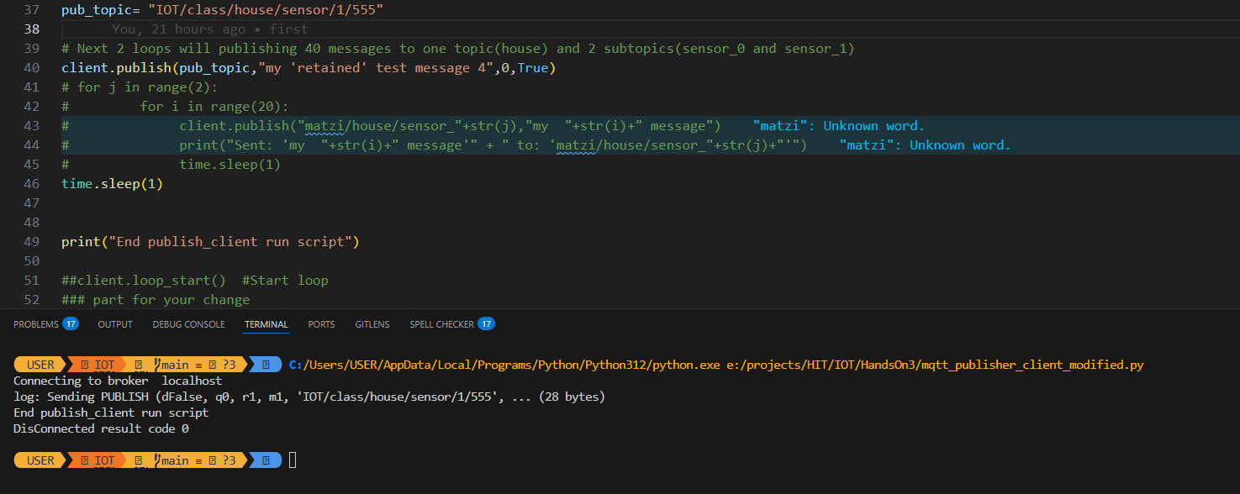
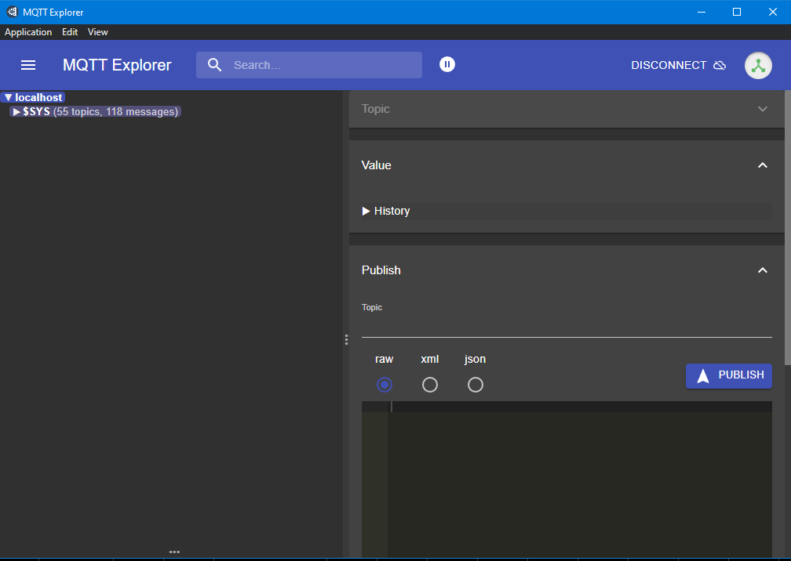
There is no IOT topic.

TEST 2 - Clean session false, QOS 0, not retained:
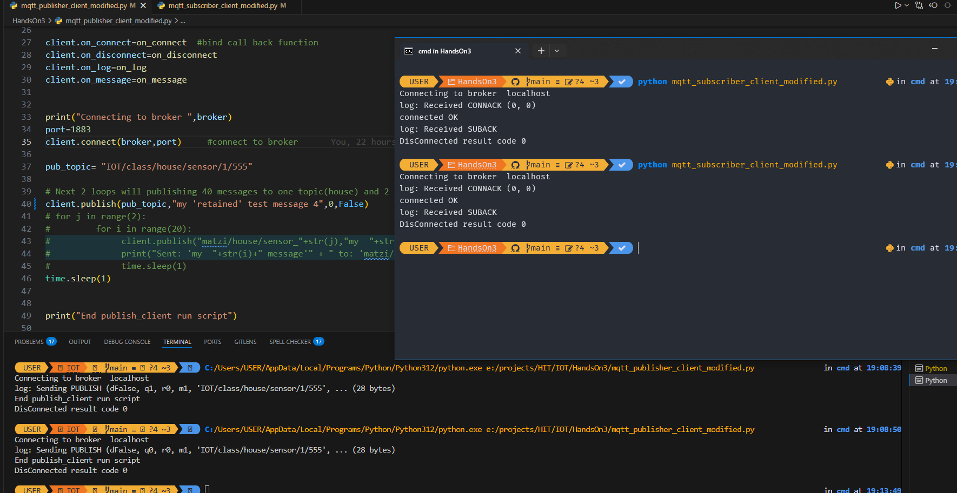
No message received.
TEST 3 - Clean session true, QOS 1, not retained:
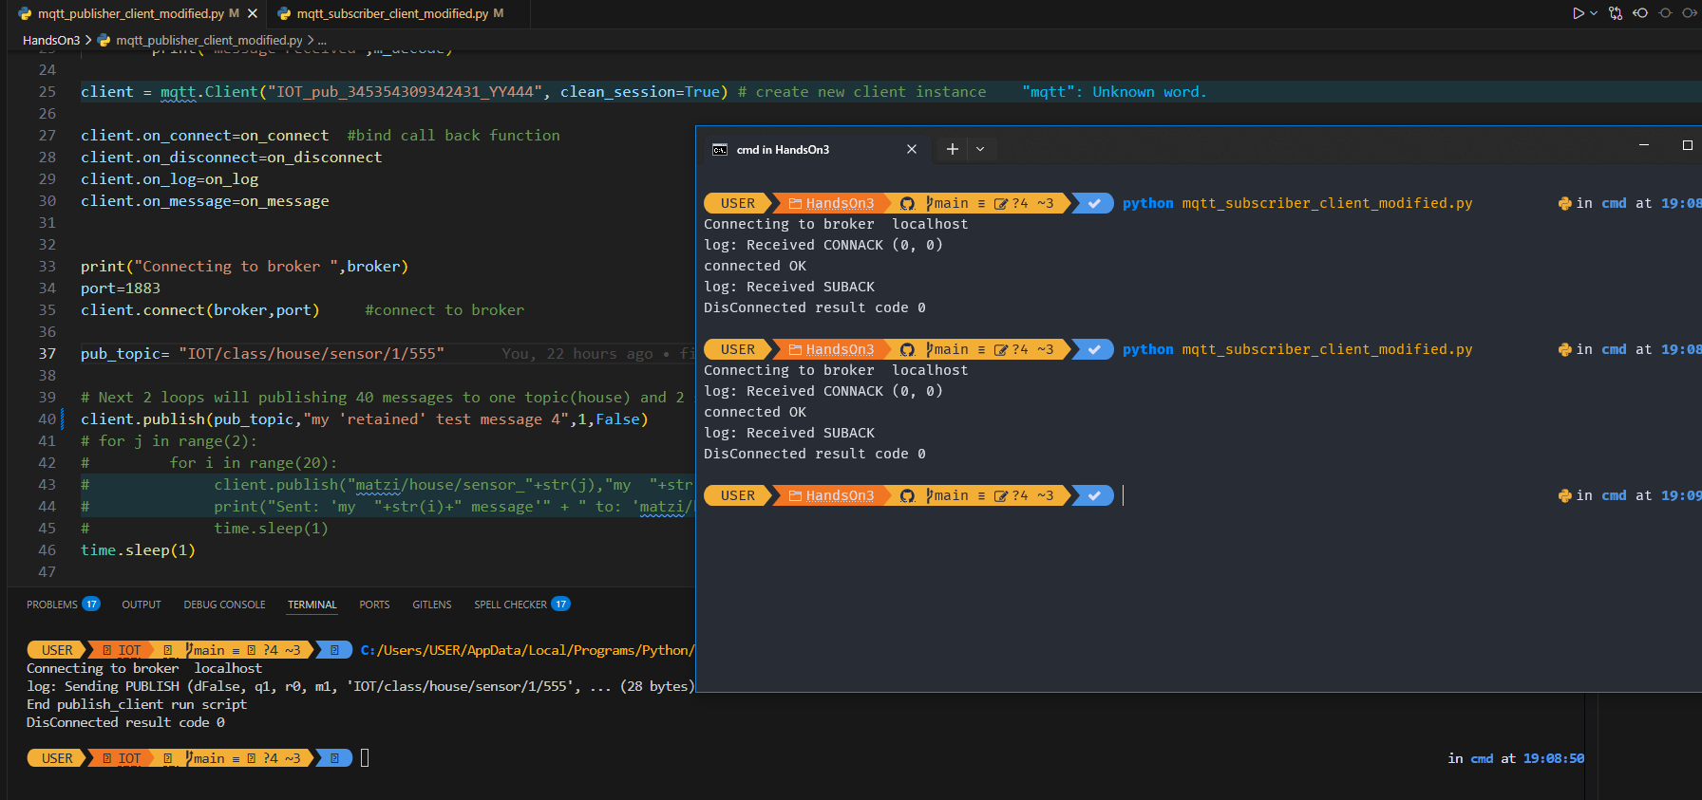
No message received.

TEST 4 - Clean session false, QOS 1, not retained:
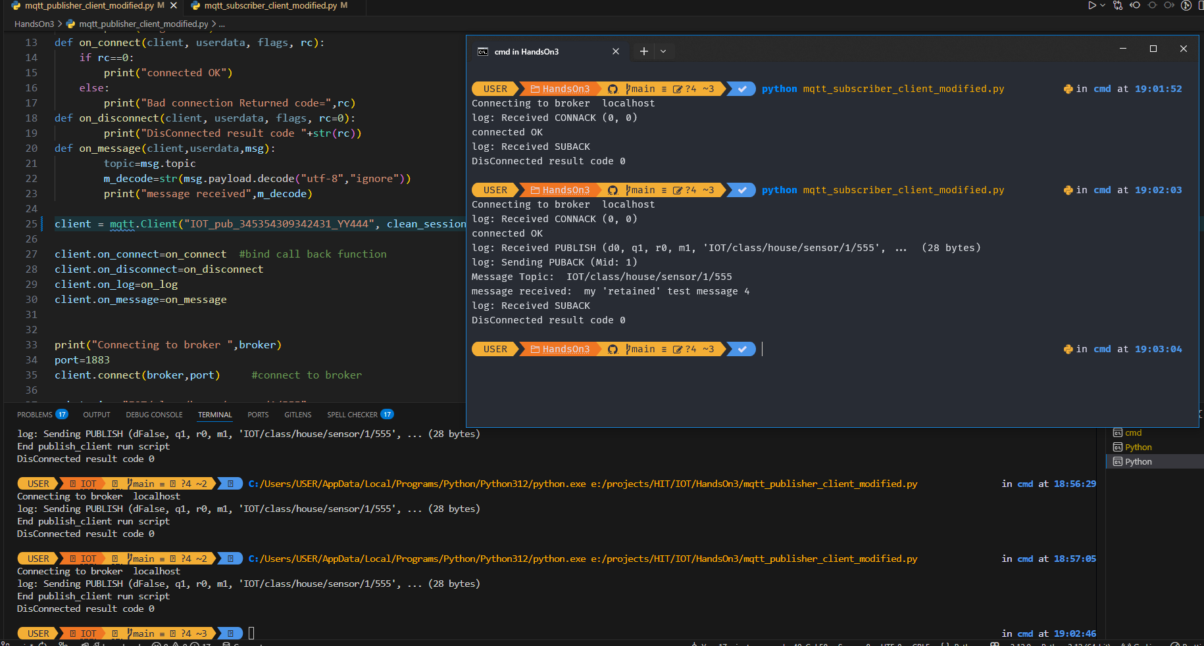
After connecting once the message was delivered even if the subscriber wasn’t connected at the time of the publish.
TEST 5 - Clean session false, QOS 1 subscribe QOS 0 publish, not retained:
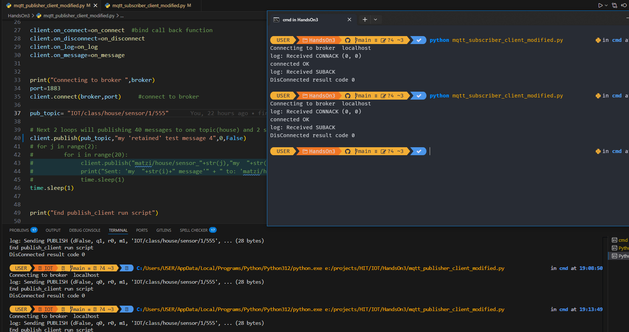
No message received.
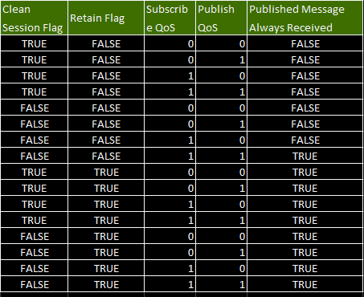

Only when clean session is false and both publish and subscribe Qos is > 1 the message will always be received but the subscriber have to connect at least once. When the message is retained it will always be delivered.

